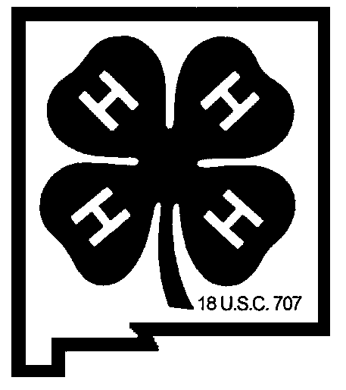New Mexico 4-H Hall of Fame
Nomination Form – Due June 1st of odd-numbered years

The New Mexico 4-H Hall of Fame has been established to recognize individuals who have had a significant impact upon the 4-H Youth Development Program.

Eligibility: Anyone who has made a significant contribution to the development of 4-H or 4-H’ers in New Mexico. Current 4-H faculty and staff are not eligible. Nominees may be living or deceased. Nominations will be accepted from any person or group.

Nominee: _____________________________________________________________________
Address: _________________________________ Town – Zip:_________________________
County: _________________________________ Phone: ____________________________
If deceased, name and address of nearest living relative: ________________________________
_____________________________________________________________________________

Please provide a brief nomination statement, using the following points as a guideline. Use one (1) additional sheet of paper. Also include a photograph of the nominee. Incomplete nominations will not be considered.

Information should include:
- Nominee’s significant contribution to 4-H. Be specific.
- Impact of the contribution.
- Role played (4-H member, club leader, project leader, fair superintendent, Extension faculty/staff, advisory boards, Foundation trustee, other volunteer, etc.).
- Length of commitment.
- Impact on 4-H, either upon individuals or the entire program.

Other factors as appropriate:
- Impact on the community
- Major career accomplishments
- In what ways has the nominee already been recognized, such as other awards, etc.

Nominator Contact Information (you may be contacted for further information):
Your Name: _______________________________ Relationship to Nominee: _____________
Address: ________________________ Town – ZIP: ______________________________
Phone: ________________________ E-mail: ___________________________________

Send this form to:
State 4-H Office, Attn: Hall of Fame – MSC 3AE, NMSU, P. O. Box 30003, Las Cruces, NM 88003-8003. Phone: (575) 646-3026; E-mail: state4h@nmsu.edu

